REGISTRATION FORM

FOURTH TERM 2022: Registration Form
- 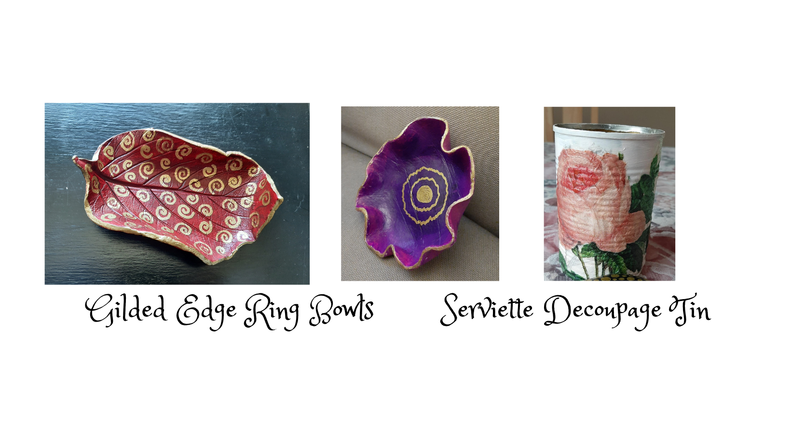DULT ENRICHMENT

REGISTRATION FORM TERM 3 2024

Surname: First Name:
Address:
E-Mail:
Telephone (H) | (W) | (Cell)
Where did you hear about us? Please tick the relevant box:
□ I’m a parent or past pupil/parent of the school
□ I’m on the mailing list and receive the CEP newsletter
□ Through social media
□ Word of mouth
□ Other: Please specify
Please indicate which THIRD TERM 2024 courses you would like to register for:

Course Title: Course Fee
(see Prospectus)
Course Title: Course Fee
(see Prospectus)
Course Title: Course Fee
(see Prospectus)
Course Title: Course Fee
(see Prospectus)
Course Title: Course Fee
(see Prospectus)
Total enclosed: |  | R
Please indicate whether you would like to be placed on our free electronic mailing list.  Only select this option if you have NOT been receiving the prospectus via e-mail. |  | Yes | No
I have read and accept the Registration and General Information in this C.E.P. Prospectus:

Signed: ________________________________________________
THE FOLLOWING FORMS OF PAYMENT ARE ACCEPTABLE:

EFT, Debit or Credit card payments are acceptable. EFT payments/Direct Deposits should be made payable to BERGVLIET HIGH SCHOOL.

DIRECT BANKING DETAILS: ABSA Bank, Account Name: Bergvliet High School
Current Account No: 4078183123 Branch Code: 632005 Reference: CEP + YOUR FULL NAME.
N.B. Please e-mail this registration form along with proof of payment to: kmiles@bhs.org.za
Alternatively, you may register in person at the school on weekdays from 08:30 – 15:30, during the school term.
Registration Queries: Contact the CEP Office: 021 713 7999 or Katharine Miles: 082 409 2195.

