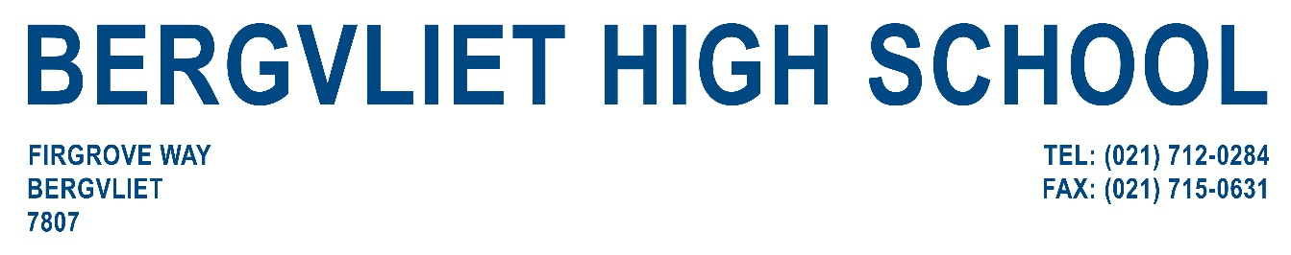


BOOKING REQUEST FORM FOR PAVILION HIRE

The Bergvliet High School Pavilion can accommodate 100 people for a cocktail type function. The facilities contain M and F toilets, kitchen facilities and a balcony. Chairs and trestle tables are available.

PLEASE FILL IN THIS FORM AND RETURN IT TO THE ADDRESS BELOW.

NAME OF ORGANISATION____________________________________________

CONTACT NAME__________________________TEL:____________________

FAX/EMAIL_______________________________

PREFERRED DATES AND TIMES OF HIRE: _________________________________

SET UP TIMES_____________________________________________

ALTERNATIVE DATES/TIMES_____________________________________________

PURPOSE FOR WHICH THE PAVILION WILL BE USED:

__________________________________________________________________

__________________________________________________________________

ESTIMATED NUMBER OF PEOPLE_____________________________________

TABLES AND CHAIRS REQUIRED (specify) _______________________________

____________________________________________________________________

_____________________________________________________________________

FURTHER REQUIREMENTS_________________________________________________
______________________________________________________________________

PLEASE RETURN THE COMPLETED FORM TO EMAIL ADDRESS AS STATED BELOW.



