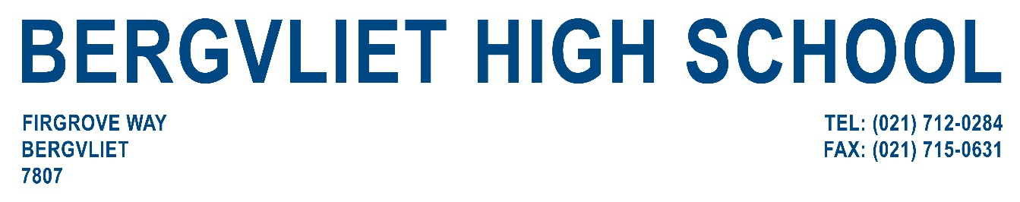


BOOKING REQUEST FORM FOR AUDITORIUM AND/OR GYM HALL HIRE

The Bergvliet High School Hall consists of: an entrance foyer, 870 numbered seats, M and F change-rooms, M and F toilets for the audience, fixed stage and general lighting (no movable spotlights) and basic microphones.
The above are the standard facilities, which are inclusive in the booking fee. Additional requirements (sound, lighting, seating/tables) as well as the use of the schools media crew (which is obligatory), are charged separately.

The Gym Hall is also available for hire as additional rehearsal space and changing facilities.

PLEASE FILL IN THIS FORM AND RETURN IT TO THE EMAIL ADDRES BELOW:

ORGANISATION NAME: _____________________________________________________________________________

CONTACT: _______________________________________________________________________________________

TEL:_____________________________________________FAX/EMAIL:______________________________________

ID NUMBER________________________________________________

DATE/S OF HIRE:

AUDITORIUM ______________________________________________________________________________________

GYM HALL___________________________________________________________________________________

PURPOSE FOR HIRE: __________________________________________________

DATE AND TIMES OF PREP-TIME/SET-UP/REHEARSAL:

DATES AND TIMES OF EACH PERFORMANCE:

__________________________________________________________________________________________

MEDIA PROVIDE BASIC LIGHTING AND SOUND ONLY.

OTHER/COMMENTS: __________________________________________________________________________
____________________________________________________________________________________________
PLEASE RETURN THE COMPLETED FORM TO EMAIL ADDRESS AS STATED BELOW.



